Title: | < Detailed Design Of Software >  SW Component < Window >

History
Issue status  (Index) | Maturity/Date  (draft/invalid/valid)  (dd-mmm-yyyy) | Author  Department | Check/Release  Department | Description
1.0 | Draft  06-sept-21 | Marco Granados | Marco Granados | Creation of the document

Table of Contents
1 Purpose 3
2 Definitions and abbreviations 3
3 Realization constraints and targets 3
4 SW Conceptual design 3
5 SW Component internal breakdown 4
5.1 Functional Decomposition 4
5.2 Function <Type> <function name> (type par 1, .., type par n) 5
5.3 Function <Type> <function name> (type par 1, .., type par n) 5

Purpose
This Document was created for have a detailed Component “Window” that can help us to make the work most easy

Definitions and abbreviations
Definitions
Special Byte  Glitches | Special byte received to change the baud rate 55h  Usually temporary malfunction or irregularity of equipment.

Abbreviations
Only SW Component specific abbreviations.
References
N° | Document name | Reference
1 | HW/SW Component

Realization constraints and targets

An overview of which are the goals that must be achieved with these functionalities.

SW Conceptual design
The Component function implies to monitor periodically a signal and increment counters.
The Components the all buttons used on the system shall use a inverted logic.
The Component use a mechanism to discard glitches on the buttons

SW Component internal breakdown
For complex SW Components, the designer may define SW Subcomponents. Please consider also the work step "Deal with complexity" provided by the method for Detailed SW Design.
Note: SW Subcomponents are synonymous with the previous used term "Module"
Mapping to the file structure:
- Non complex SW Components should be represented by one object file.
- For complex SW Components each SW Subcomponent should be represented by one object file.
<Subcomponent decomposition if applicable>

Functional Decomposition
Overview of functions and their dependencies shown by a Static Function Tree
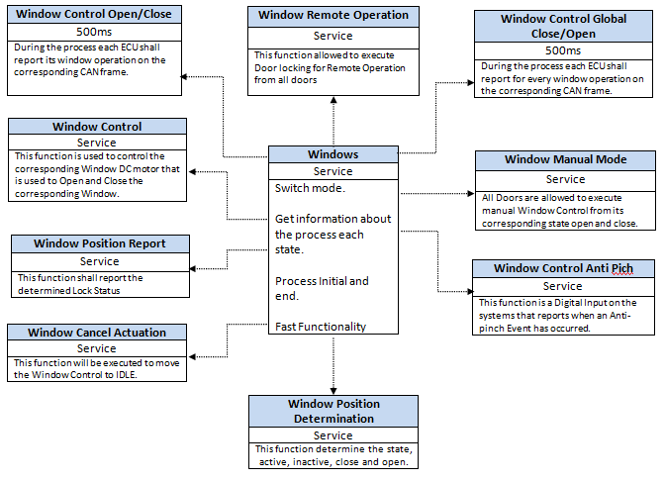
Function Description and Dynamic Behavior
Provide detailed static and dynamic description of all functions of the SW Component.
Functions which are defined in other SW Components shall only be referenced in the external interface description!
The signature description shall be done inside the function header in the source code.
For each function, the following section should be copied

Function <Type> <function name> (type par 1, .., type par n)
Functional, Window Control Open/Close
During the process each ECU shall report its window operation on the corresponding CAN frame.
Description | During the process each ECU shall report its window operation on the corresponding CAN frame.
Parameter 1  <input| output| inout> | Out
Parameter 2..n | -
Return Value | None
Precondition | Function can only be Open and Close a Window
Post condition | Close/Open
Error Conditions | It cant pressing button close and button Open at the same time
Requirements | DCU_SWR_36-42, DCU_SWR_50-56

Functional, Window Remote Operation
This function allowed to execute Window open for Remote Operation from all Windows.
Description | This function allowed to execute Window open for Remote Operation from all Windows.
Parameter 1  <input| output| inout> | Inout
Parameter 2..n | -
Return Value | Position
Precondition | allowed execute Window open for Remote Operation
Post condition | Close/Open
Error Conditions | It cant pressing button close and button Open at the same time
Requirements | DCU_SWR_87 - 106

Functional, Window Control Global Close/Open
During the process each ECU shall report for every window operation on the corresponding CAN frame.
Description | During the process each ECU shall report for every window operation on the corresponding CAN frame.
Parameter 1  <input| output| inout> | Out
Parameter 2..n | -
Return Value | None
Precondition | Function can only be Open and Close a global Window
Post condition | Close/Open
Error Conditions | It cant pressing button close and button Open at the same time
Requirements | DCU_SWR_57 – 63, DCU_SWR_43 - 49

Functional, Window Control
This function is used to control the corresponding Window DC motor that is used to Open and Close the corresponding Window.
Description | Brief description of the function behavior and useful remarks
Parameter 1  <input| output| inout> | Out
Parameter 2..n | -
Return Value | None
Precondition | Window DC motor that is used to Open and Close the corresponding Window
Post condition | Close/Open
Error Conditions
Requirements | DCU_SWR_31-35

Functional, Window Position Report
This function shall report the determined Lock Status.
Description | Brief description of the function behavior and useful remarks
Parameter 1  <input| output| inout> | inout
Parameter 2..n | -
Return Value | Position
Precondition | report the determined Lock Status
Post condition | Report
Error Conditions | it shall report the determined Lock Status
Requirements | DCU_SWR_116 -119

Functional, Window Cancel Actuation
This function will be executed to move the Window Control to IDLE.
Description | This function will be executed to move the Window Control to IDLE.
Parameter 1  <input| output| inout> | in
Parameter 2..n | -
Return Value | Cancel
Precondition | executed to move the Window Control
Post condition | Cancel
Error Conditions | move the Window Control
Requirements | DCU_SWR_64, DCU_SWR_65

Functional, Window Position Determination
This function determine the state, active, inactive, close and open.
Description | This function determine the state, active, inactive, close and open.
Parameter 1  <input| output| inout> | inout
Parameter 2..n | -
Return Value | State
Precondition | determine the state, active, inactive, close and open
Post condition | State
Error Conditions | -
Requirements | DCU_SWR_111 - 116

Functional, Window Control Anti Pich
This function is a Digital Input on the systems that reports when an Anti-pinch Event has occurred.
Description | This function is a Digital Input on the systems that reports when an Anti-pinch Event has occurred.
Parameter 1  <input| output| inout> | input
Parameter 2..n | -
Return Value | Anti Pinch
Precondition | Anti-pinch Event has occurred.
Post condition | Anti Pinch
Error Conditions | Pinch
Requirements | DCU_SWR_107 - 110

Functional, Window Manual Mode
All Doors are allowed to execute manual Window Control from its corresponding state open and close.

Description | All Doors are allowed to execute manual Window Control from its corresponding state open and close.
Parameter 1  <input| output| inout> | out
Parameter 2..n | -
Return Value | none
Precondition | execute manual Window Control
Post condition | Close/Open
Error Conditions | -
Requirements | DCU_SWR_66 - 86

Dynamic Behavior
State Chart¹, Flow Chart¹
¹ Preferred
In this document, the dynamic behavior shall be designed on an abstract level showing the principle workflow of a function. Do not show the detailed implementation to ensure that the design description can be maintained with a reasonable effort. The target is not to show the complete detailed implementation 1:1.
The detailed design shall reflect in detail what a function is doing from a black box view. The internal details are useful on an abstract, but not very detailed level.
If the function is not complex a short textual description might be enough, and a graphical description is not needed.
Symbol and function names shall be self explaining.
The link to the implementation may be provided by using the same names as in the design or by a comment showing the full name followed by the declaration showing the implementation.
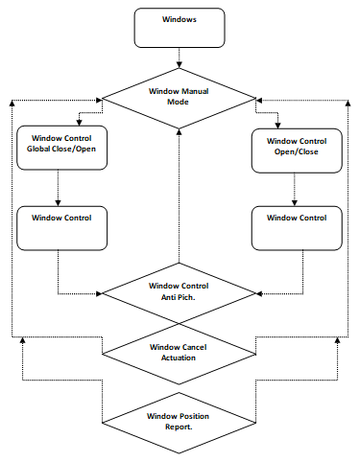

Function <Type> <function name> (type par 1, .., type par n)
Description | Brief description of the function behavior and useful remarks
Parameter 1
<input| output| inout>
Parameter 2..n
Return Value
Precondition | e.g. Function can only be called in a certain state, SW component is initialized  Relation between input parameters where applicable (Input for Module Test)
Post condition | e.g. specific State change e.g. car is locked, EEPROM Values written,  Relation between output parameters where applicable
Error Conditions
Requirements

Dynamic Behavior
State Chart¹, Flow Chart¹, Nassi Shneiderman
¹ Preferred
In this document, the dynamic behavior shall be designed on an abstract level showing the principle workflow of a function. Do not show the detailed implementation to ensure that the design description can be maintained with a reasonable effort. The target is not to show the complete detailed implementation 1:1.
The detailed design shall reflect in detail what a function is doing from a black box view. The internal details are useful on an abstract, but not on a very detailed level.
Symbol and function names shall be self explanatory.
The link to the implementation may be provided by using the same name as in the design or by a comment showing the full name followed by the declaration showing the implementation.

